

**Basic Linux Commands Assignments**

Assignment-1

Connect and disconnect with login Access

* What happens when you login a non-existent users or username?
  + Provide Screenshot and What you understand, explain in short brief?

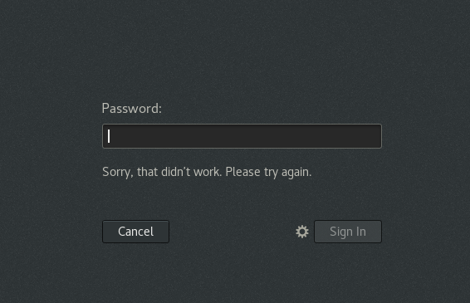

When I tried login with the incorrect User name and clicked on Next it asked for the password. Got an error “Sorry, that did not work. Please try again” after typing the password. Did not allow to complete booting to the user profile.

Assignment-2

Password changing

* Login into your account and then change password?
  + Change your password into ***IneuR0n#42*** and hit the **Enter** key
    - Explain what happen and give screenshot?

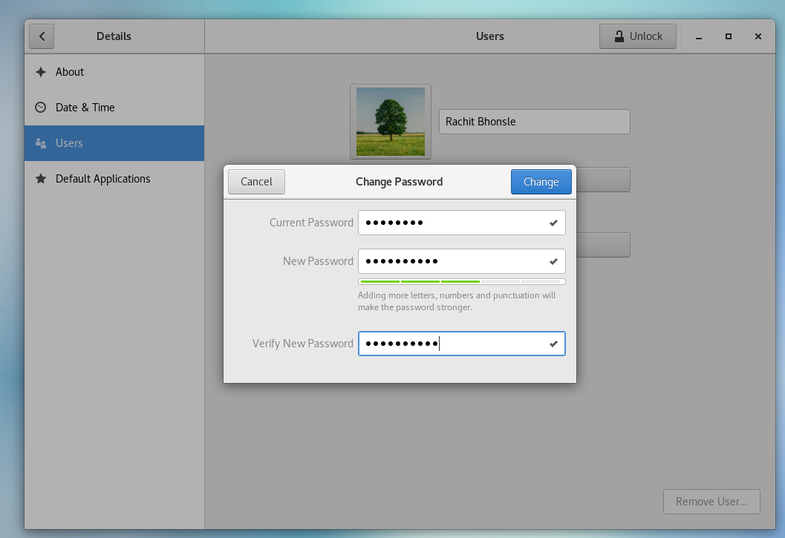

After entering the given password..it was showing how strong the password with the Green/red and amber colour.

* + Try again to change password but use like password ***1234*** or ***abcd***
    - Explain what happen and give screenshot?

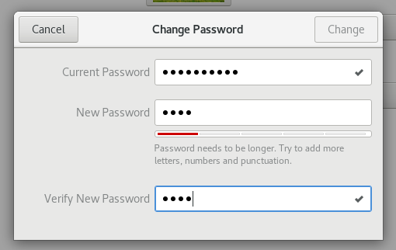

when we try to enter the password “abcd”or “1234” it was showing the password is weak suggesting to add more letters,numbers and punctuations

* + Try again to change password but now don’t use any password just hit **Enter** key
    - Explain what happen and give screenshot?

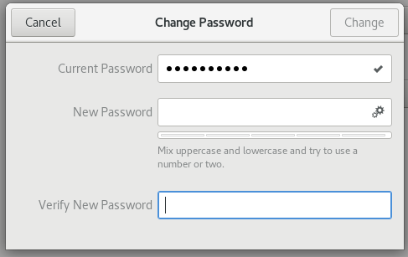

The change button is disabled and did not allow to keep the password as empty.

Assignment-3

Working with Directories

* Enter the command **cd /** and then **ls** and then hit **Enter** key
  + Take screenshot and explain what output we got?

Cd /home

`/` as an argument in `cd` we can change the directory to the root directory. The root directory is the first directory in your filesystem hierarchy.

* Enter the command now **cd /home** and then hit **Enter** key
  + Do **ls,** provide screenshot and explain what is **/home** directory used for?



It went into the “home” directory and with “ls” command able to see the present directory

* Enter **cd ..** and hit **Enter** key [ *Note: here we have space after cd then use double dot*]
  + Check what happen and give screenshot?

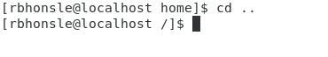

“..” Represent parent directory. “cd” with “..”command wil move to the parent directory from of the current directory

* Now enter **cd /var/www/html** and then type **cd** and hit **Enter** key
  + Explain what happen and give screenshot?

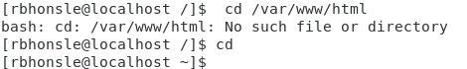

I was getting error since there is no folder called www and html

* Now type **cd /root** and then hit **Enter** key
  + Do **ls,** check any output we have on screen if yes then take screenshot?

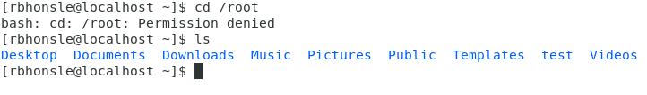

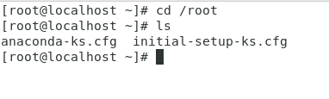

Getting error message when tried from the local user.. Tried to get into root and tried the cd command got couple of cfg files listed.

Assignment-4

Working with File Listing

* Go to **cd /etc** and type **ls**
  + Take screenshot and explain what files you have seeing?
  + Take screenshot and explain what different output you found compare to previous command you used?

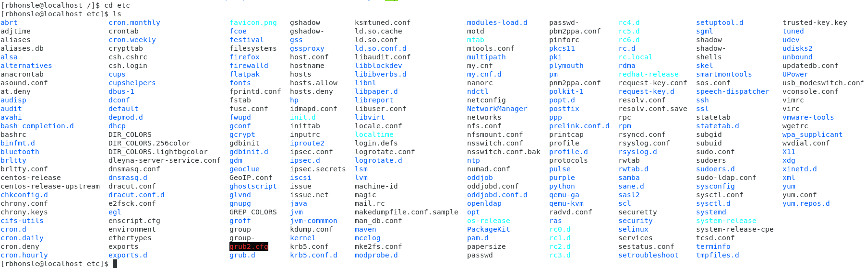

Etc directory contains System Configuration information. Ls Command helped to see all the files,sub directories that etc contains.

Root folder was has only couple of cfg files but the etc contains all the system configuration files.

* Then type **ls -al** and hit **Enter** key
  + Take screenshot and explain what new file or directory you found?

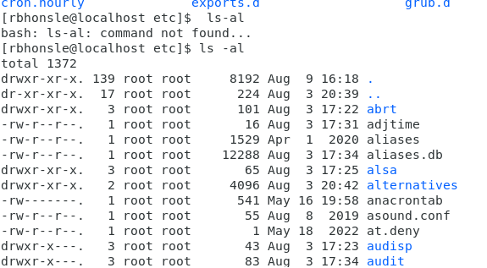

It shows the read, write and execute permission for user/group/others for all the directories and files

* Then use **ls -i** and hit **Enter** key
  + Now see what different output its shows and take screenshot?

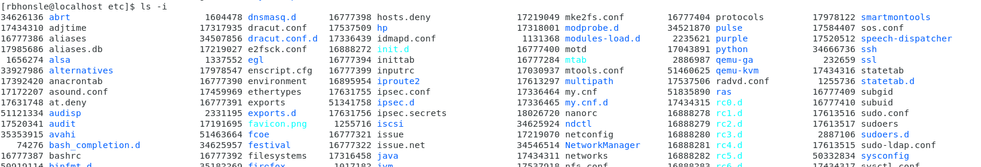

Size for all the files and directories

* Then use **ls –help** and see other options about **ls** command
  + Explore it and try with other attribute we can use with **ls** command

--help shows all the option and commands to be used along with the list command

Assignment-5

Know where you are and where you working

*Here we use* ***pwd, cd and ls*** *as combine task to understand where you working on terminal and how you can switch from one directory to another one.*

* Open terminal after restart the linux
  + Check which location you working, type **pwd** and take screenshot
* Now use **cd /var** and hit **Enter** key
  + Do **ls,** and see what output comes, give screenshot?
* Do explore other help options of each command to learn more other things we can do with these commands

